

 e-ISSN 1679-0375

FORM

### AUTHORS

## CRediT FORM

The journal Semina: Exact and Technological Sciences from 2023 on adopted the system of taxonomy papers for [**CRediT**](https://credit.niso.org/) contributors. **CRediT** is a taxonomy of 14 papers that describe the authorial contribution in the making of academic productions. Therefore, all manuscripts submitted to the journal must describe the participation of their authors by completing this form, aiming to collect information about the authors' contributions. The contributions should be accurately listed for each author mentioned in the text. Please use the CRediT Taxonomy listed in this form for the description.

Approved articles will have its authorial contributions published, independent of the contribution, all authors are equally responsible for the article.

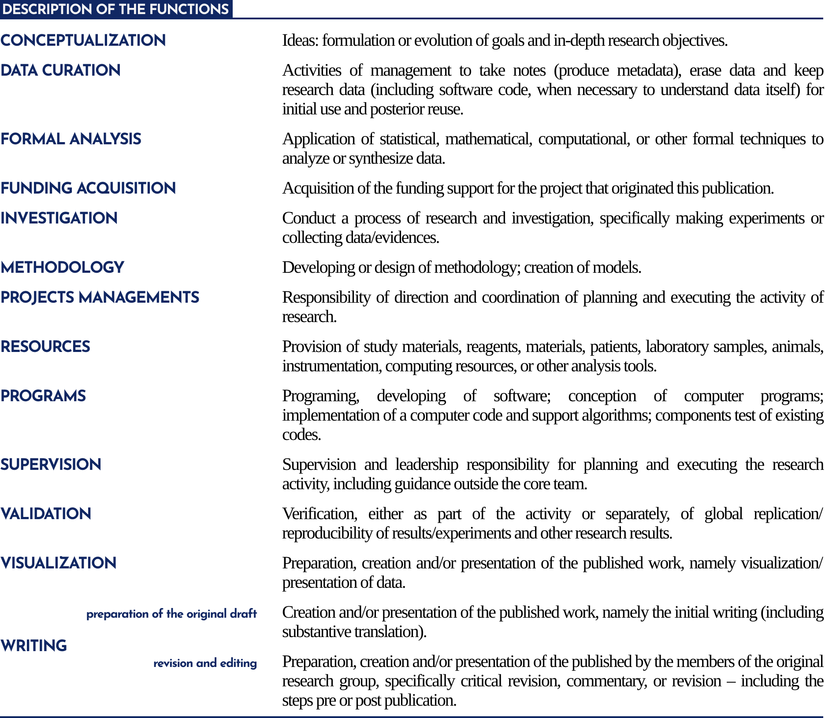

# 1 DESCRIBE THE CONTRIBUTIONS FOLLOWING THE EXAMPLE:

Author 1: Conceptualization, Data Curation, Formal Analysis, Investigation, Methodology, Writing – original draft.

Author 2 and Author 3: Supervision, Validation, Visualization, Writing – revision and editing.

Description

# 2 DOES THIS STUDY HAS FUNDING FROM ANY RESEARCH AGENCY?

Specification

( ) Yes. Specify:

( ) Does not apply

# 3 IS THERE ANY COMMERCIAL OR ASSOCIATIVE CONFLICT OF INTEREST IN RELATION TO THE MANUSCRIPT?

Specification

( ) Yes. Specify:

( ) No. The authors certify that there is not a commercial or associative interest that represents a conflict of interest in relation to the manuscript.

03/08/2023

Date

Place

